Introduction to OOP

Good Software
Before jumping into Object Oriented Programming, let’s understand the word Software.

Software is an easily changeable tool/product that performs a specific task.

The ease of changing or making changes to the software is referred as its softness.
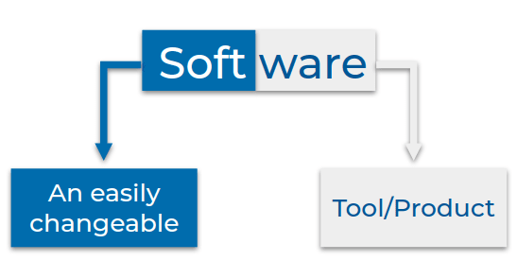
- A good software should keep the users happy, by delivering what they need.
- A good software should also keep the developers happy. Ease of making changes (softness) keeps developers happy. So is should be:
  - Easy to understand and make changes.
  - Easy to fix bugs and add new features within the scope.
Object-Oriented Programming System (OOPS) is a way of approaching, designing, developing software that is easy to change.
Keep in mind that building software differs from solving the coding questions (that you are doing in practice).
A fundamental difference is that you move on to the next problem once you solve a coding problem. But with software, once you build it, you are often required to add new features and fix bugs that need you to make changes to the code written by you or your colleagues. So unlike the coding questions, with software, you have to keep working with the same code for a long time.
Therefore, ease of understanding (code-readability) and ease of making changes (code-maintainability) to the code become crucial in software development.
The techniques and concepts you learn in this topic are developed over time based on software developers' experiences to make working code easier.

OOPs
Object-Oriented Programming is a way of approaching, designing and developing software, so that the components of the software and the interactions between them resembles real-life objects and their interactions.
Proper usage of OOPS concepts helps us build well-organized systems that are easy to use and extend.

Describing Real-Life Objects
In Object Oriented Programming, we model software after real-life objects. To be good at modeling software after real-life objects, we should be able to properly describe them.

Let us try describing these real-life objects
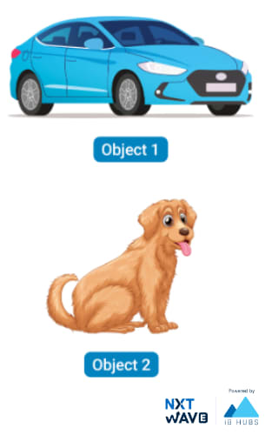
The following description is a bad way of describing, as the information of an object scattered and unorganized.
Object 1 is a car and it has four tyres.
Object 2 is a dog and it has four legs.
Object 1 has four doors.
Object 1 can make sound.
Object 2, barks.
Object 1 is in blue color.
Object 2 is in brown color.

Organized Description
- In the below description we are grouping the information related to an object.
Object 1 is a car and it has four tyres.
Object 1 has four doors.
Object 1 can make sound.
Object 1 is in blue color.
Object 2 is a dog and it has four legs.
Object 2, barks.
Object 2 is in brown color
- In the below approach, we further organize the information into
  - What the object is?
  - What the object has?
  - What the object can do?

Object 1 is a car
Object 1 has
Four tyres
Four seats
Four doors
and so on ...

Object 1 can
Sound horn
Move
Accelerate
and so on ...

Object 2 is a dog
Object 2 has
Brown fur
Four legs
Two ears
and so on ...

Object 2 can
Bark
Jump
Run
and so on ...

The above description shows a simple framework where we describe object by specifying the properties that the object has and actions that the object can do.
Organized Description should be
- A clear separation of objects.
- A clear grouping of what object has and what it does.

Describing Similar Objects
Sometimes, the objects that we are describing are so similar that only values of the properties differ.
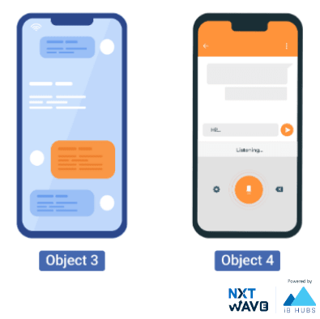

Object 3 is a Mobile
Properties
camera : 13 MP
storage : 16 GB
battery life : 21 Hrs
ram : 3 GB
and so on ...

Object 4 is a Mobile
Properties
camera : 64 MP
storage : 128 GB
battery life : 64 Hrs
ram : 6 GB
and so on
In this case, the objects that we describe have completely the same set of properties like camera, storage, etc.

Template
For objects that are very similar to each other (objects that have the same set of actions and properties), we can create a standard Form or Template that can be used to describe different objects in that category.
Mobile Template
Model :
Camera:
Storage:
Does it have a Face Unlock? Yes | No
Filled Template
Model : iPhone 12 Pro
Camera: 64MP
Storage: 128GB
Does it have a Face Unlock? Yes

Bundling Data

While modeling real-life objects with object oriented programming, we ensure to bundle related information together to clearly separate information of different objects.

Bundling of related properties and actions together is called Encapsulation.

Classes can be used to bundle related properties and actions.

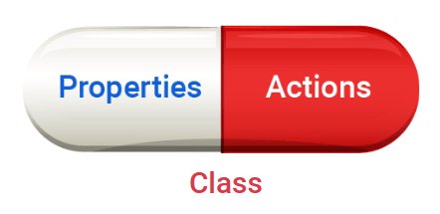

Defining a Class

To create a class, use the keyword

class

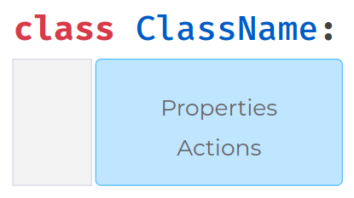
Example:
class Mobile {
String model;
int camera;
int ram;
Mobile(String model,int camera, int ram) {
this.model = model;
this.camera = camera;
this.ram = ram;
}

void makeCall(String num){
System.out.println("calling....."+num);
}
}
class Main {
public static void main(String[] args) {
Mobile onePlus = new Mobile("oneplus-10R",32, 16);
Mobile redmi = new Mobile("Redmi-c5",16,64);
System.out.println(onePlus.model);
System.out.println(redmi.model);
onePlus.makeCall("9440529030");
redmi.makeCall("9912044343");
}
}

